User Management Functional Requirements

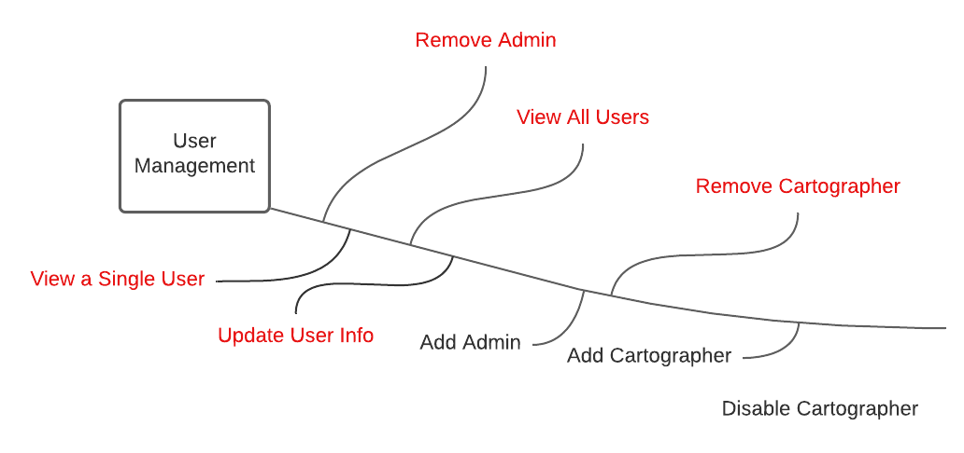

# Description

The User Management system will extent the functionality of Microsoft’s Identity Platform. This system is where Admins will be able to manage all users register with the system.

# Functional Requirements

1. The User Management System shall extend Microsoft’s ASP.NET Core Identity Platform.
2. The user management system shall always ensure that at least one user has Admin permissions.
3. The system shall allow Admins to add new Cartographers.
4. The user management system shall allow Admins to add additional Admins.
5. The system shall transfer ownership of charts and regions to specified user upon removal of their owner.
   1. The system shall prompt the Admin asking who they would like to transfer ownership too.
6. The system shall allow Admins to remove a user.
7. The system shall warn the Admin before removing a user.
8. The Admins shall have a page to view all the available users in the system.
9. The Admins shall be able to view the detailed information of a specific user.
10. The system shall allow users to update their account details.
11. The system shall allow users to rest their password.